# Site Flow and Sketches

## Step 1: Competitive Analysis

|  |  |
| --- | --- |
| Competitor Site 1: Craigslist URL: www.craigslist.com AnalysisWhat is good about this site?  1. Easy to navigate 2. Solid search results 3. No ads  What is bad about this site?  1. Font boring 2. Too much white 3. No pictures | Competitor Site 2s: eBay URL: www.ebay.com AnalysisWhat is good about this site?  1. More colors 2. Has pictures 3. Social media links  What is bad about this site?  1. Ads 2. Cluttered/ not simple 3. Pages long |

### Competitor 1 Pages

#### Page (or Screen) where you ask “What should I buy tonight?”

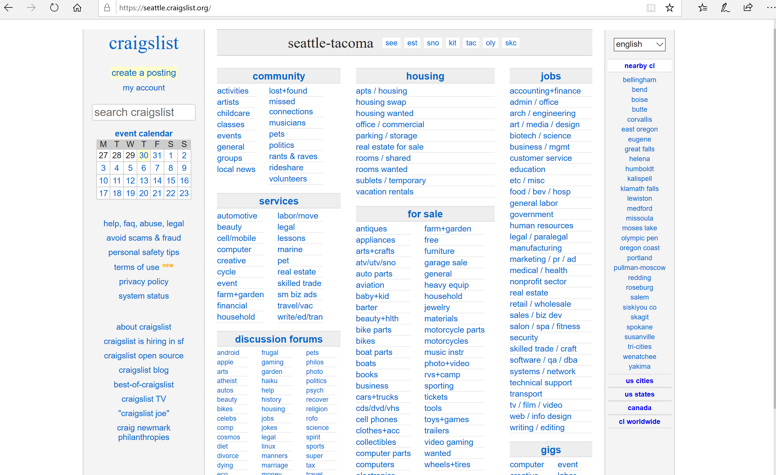

#### Pages (or Screens) look for the answer

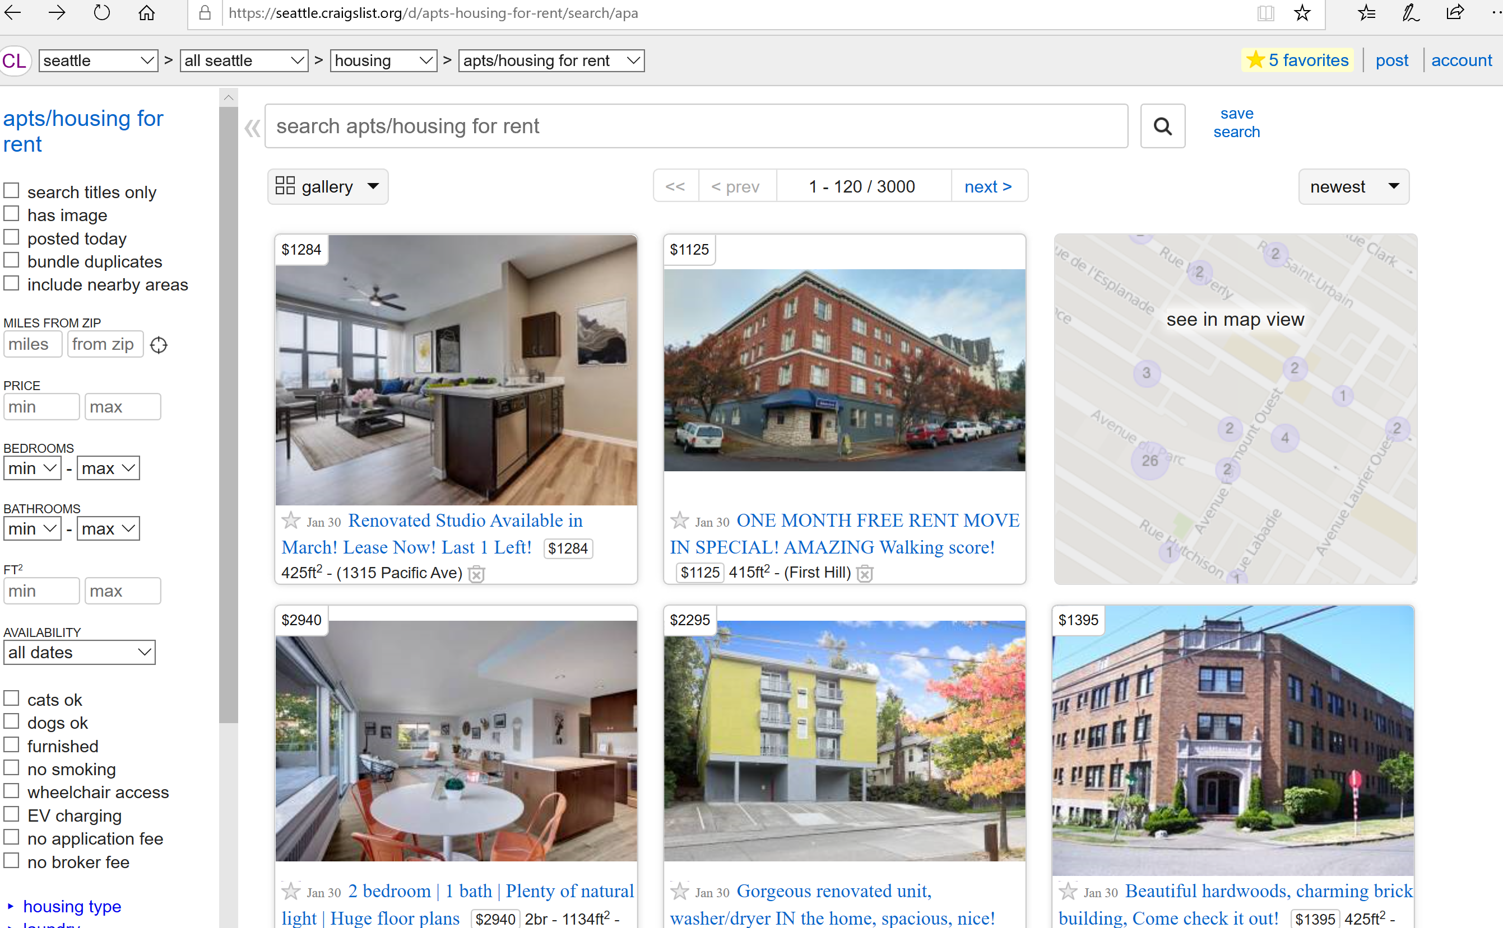

#### Page where you get an answer

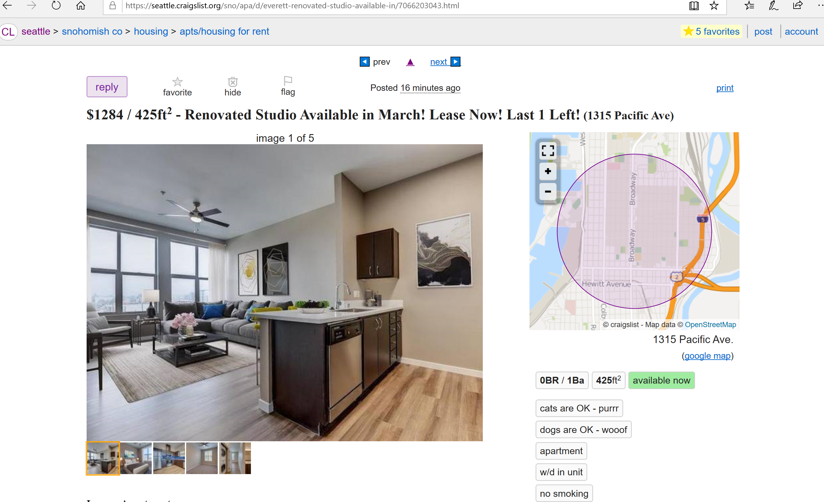

### Competitor 2 Pages

#### Page (or Screen) where you ask “What should I buy tonight?”

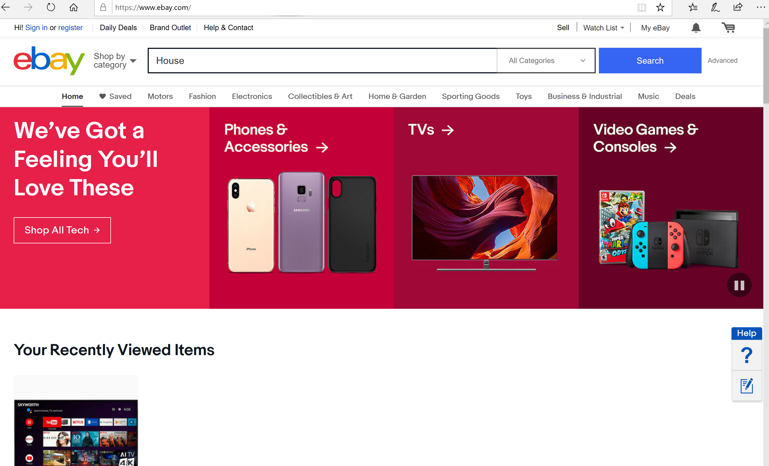

#### Pages (or Screens) look for the answer

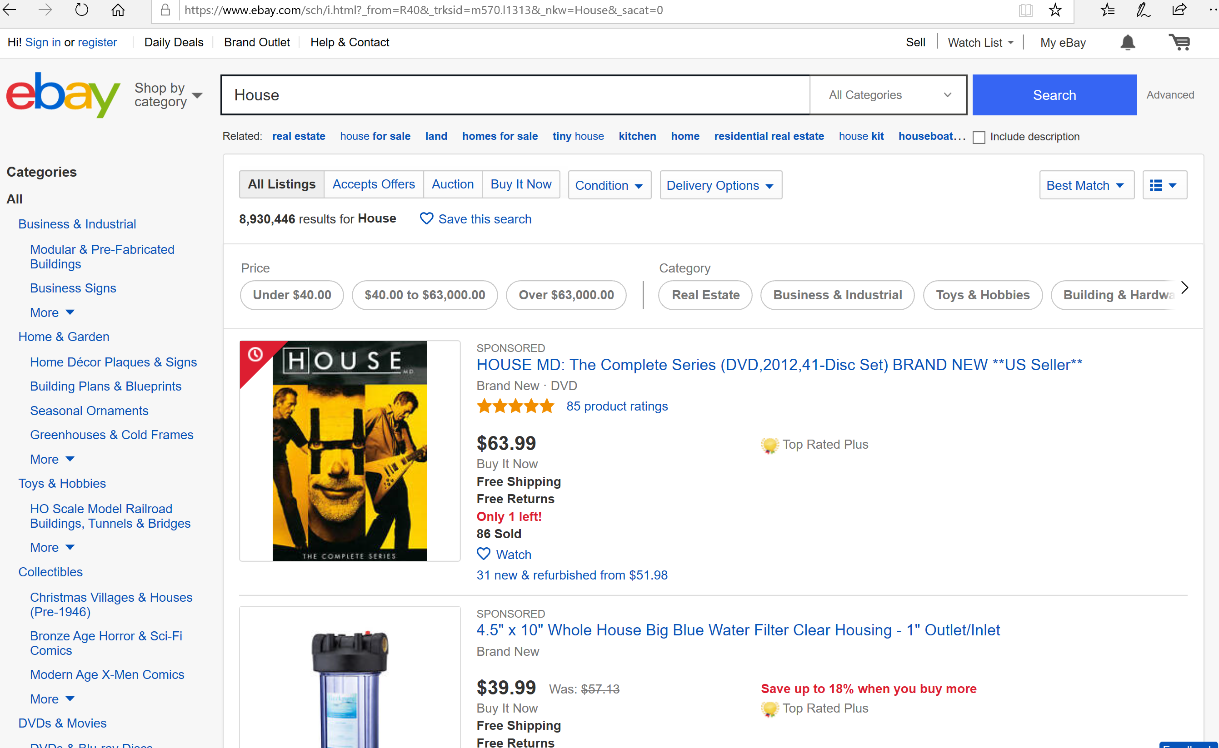

#### Page where you get an answer

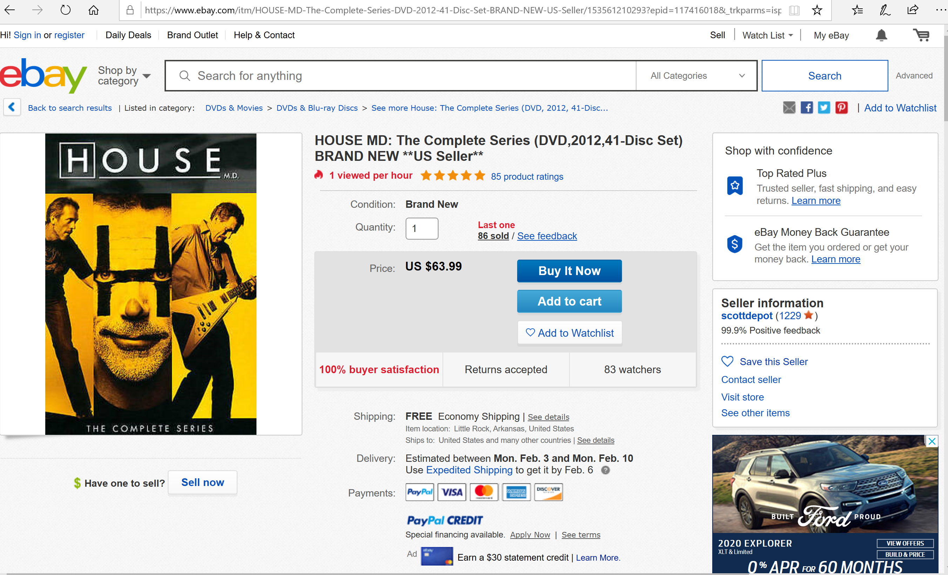

## Step 2: Sketch One Competitor Flow

### Favorite Competitor: Page Flow Sketch

Pages sketched as boxes for the flow between pages (or screens) where you ask “What should I buy tonight?”, look for the answer, and get an answer. Arrows drawn between the boxes show how the pages are connected by clicks. Inside the page boxes details include:

* Where you ask the question
* Where the navigation is that allows you to find things to do
* Where the details of the “things to buy” are displayed
* Where you click to move from page to page

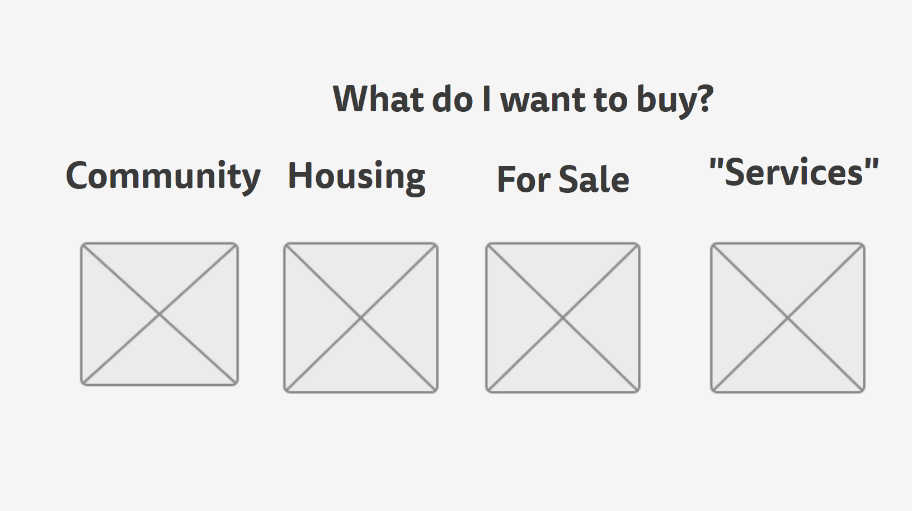 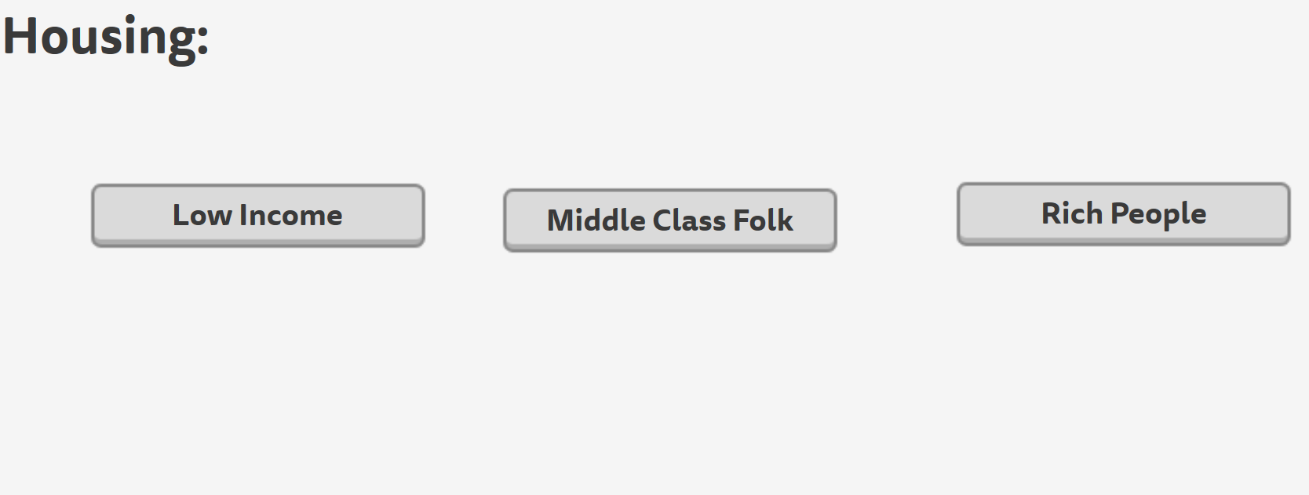



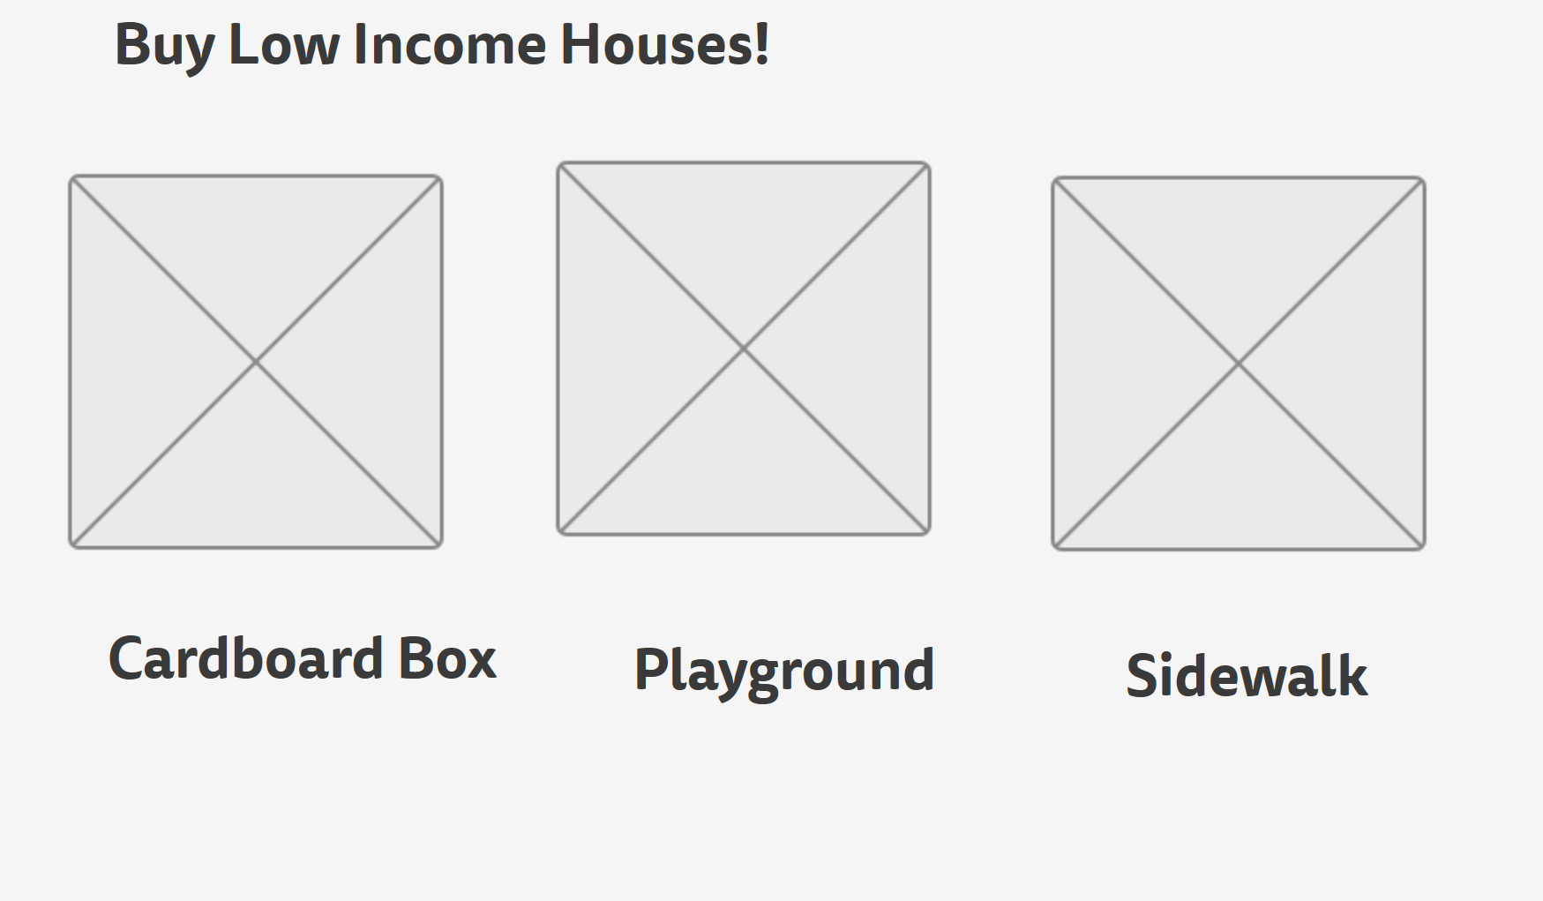

## Step 3: Sketch YOUR Flow

### My Site Name

www.bystuf.com

#### Sketch of My Page Flow

Pages sketched as boxes for the flow between pages (or screens) where you ask “What should I buy tonight?”, look for the answer, and get an answer. Arrows drawn between the boxes show how the pages are connected by clicks. Inside the page boxes details include:

* Where you ask the question
* Where the navigation is that allows you to find things to do
* Where the details of the “things to do” are displayed
* Where you click to move from page to page

